CODING PRACTICE

https://www.hackerrank.com/contests/mountblue-technologies/challenges/breaking-best-and-worst-records
https://github.com/mountblue/algorithms-learning-path

PROBLEM - 1 :
There are 2 inputs n and arr.
n is the no.of socks and arr is the socks pairs numbers
output must be the no.of pairs we can form
Logic:
count the socks by using the hashmap then using that make the pairs using the loop for freq.values() and then divison by 2 which returns the quotient
Code:
def sockMerchant(n, ar):
freq = {}
for i in ar:
if i in freq:
freq[i]+=1
else:
freq[i] = 1
pairs = 0
for count in freq.values():
pairs += count // 2
return pairs
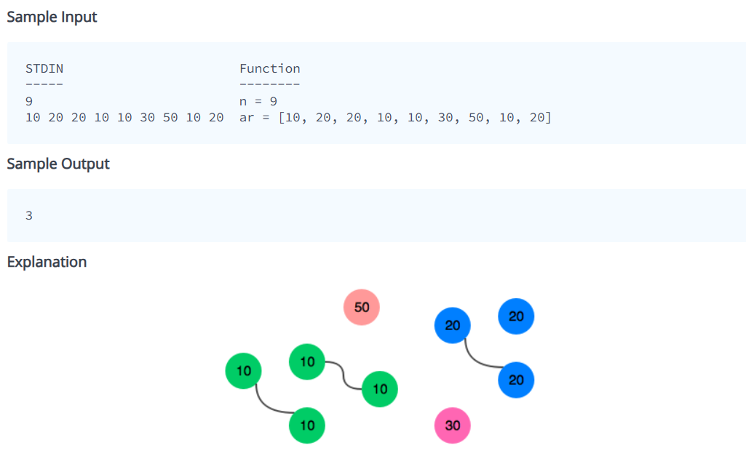

PROBLEM – 2 :
Simple array sum
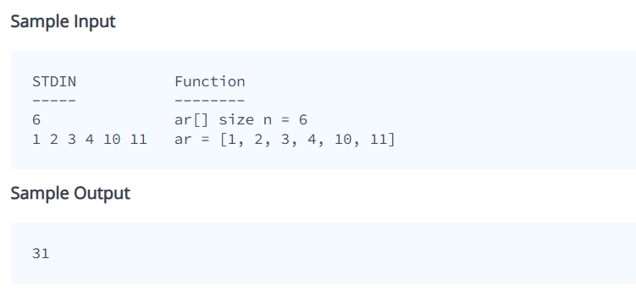

Code :
def simpleArraySum(ar):
sum = 0
for i in ar:
sum += i
return sum

PROBLEM – 3 :
• Maria plays many games.The first game score sets her starting record.
• From the next games, she checks:
- Did I score more than ever before?
- Did I score less than ever before?
• Every time this happens, she counts it.
Output:
- how many times highest score was broken
- how many times lowest score was broken
Input : arr scores
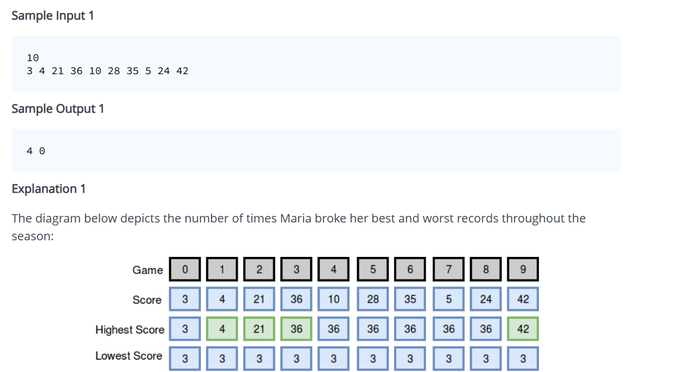
def breakingRecords(scores):
# Write your code here
high = scores[0]
low = scores[0]
max_c = 0
min_c = 0
for sc in scores[1:]:
if sc > high:
high = sc
max_c += 1
elif sc < low:
low = sc
min_c += 1
return [max_c,min_c]

PROBLEM – 4 : Print staircase
def staircase(n):
for i in range(1, n + 1)
# print spaces
for s in range(n - i):
print(" ", end="")
# print #
for h in range(i):
print("#", end="")

# move to next line
print()

